**SPH3U 5.3 Types of Energy and the Law of Conservation of Energy**

1. **Types of energy**

|  |  |  |
| --- | --- | --- |
| **Form of Energy** | **Type of Energy** | **Description** |
| **Potential and Kinetic** |  | Gravity + kinetic |
|  | Electromagnetic fields |
|  | Flowing charges |
|  | Randomly moving molecules |
|  | Oscillating molecules |
| **Potential** |  | Gravity |
|  | Static charges |
|  | Protons and neutrons |
|  | Stretched materials |
|  | Molecular bonds |

|  |  |
| --- | --- |
| Energy transformation: |  |
| example |  |

1. **The law of conservation of energy**

|  |  |
| --- | --- |
| Law of conservation of energy: |  |

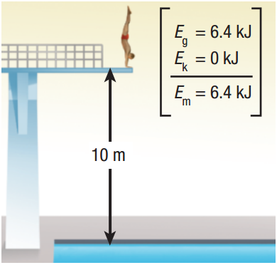

A 65.0 kg diver dives from a 10.0 m high platform into the water below. What is his mechanical energy when he is on the platform (before diving)?

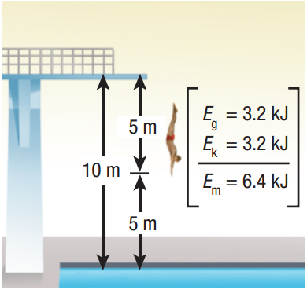What is his mechanical energy when he is halfway to the water?

What is his mechanical energy when he reaches the surface of the water?

1. **Applying the law of conservation of energy**

A 1.1 kg camera slips out of a photographer’s hands while he is taking a photograph. The camera falls 1.4 m to the ground below.

1. What is the camera’s gravitational potential energy relative to the ground when it is in the photographer’s hands?
2. Using the law of conservation of energy, determine the camera’s kinetic energy at the instant it hits the ground.
3. Use the camera’s kinetic energy to determine its speed when it hits the ground.

**Homework:** page 241: #1-4